Week 5: Introduction to Mobile Application Development
Student Name: Precious Jaiyesimi Eniola
Admission number: BIT/2024/39050
Course: Mobile Application Development
School/Faculty: Computing and Informatics, Mount Kenya University_
Program: Information Technology
Academic Year: 4th
Semester: First
Lecturer: Mr Nyoro

Task Completed
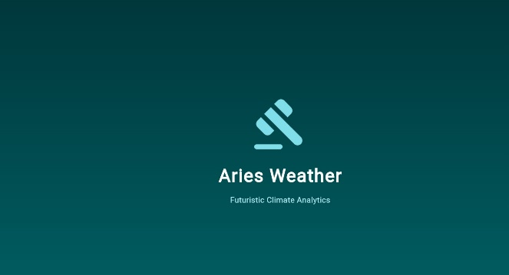
Introduction screen

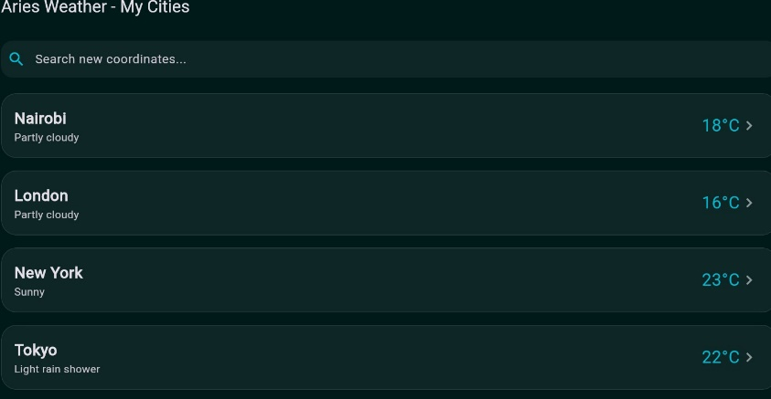
Home Screen
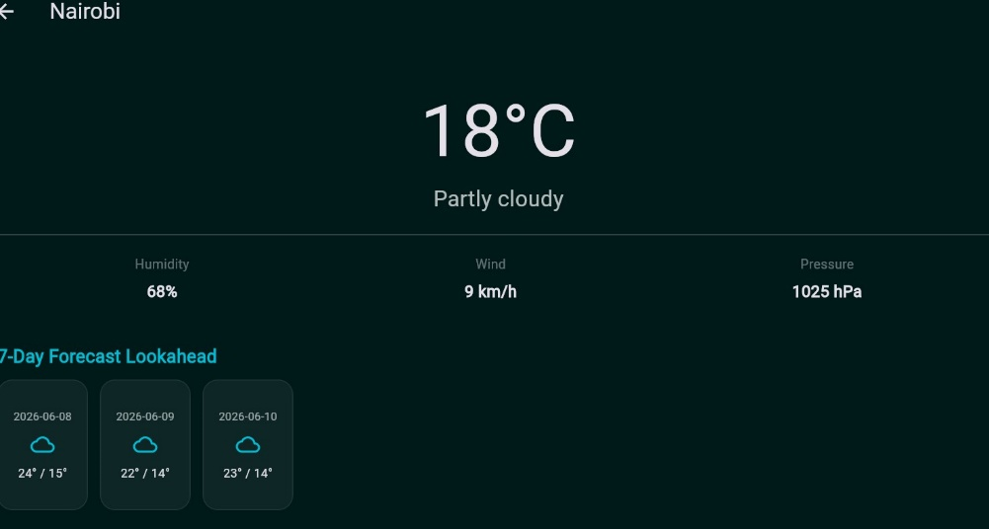
Personalized screen for Nairobi

Other task
- I Developed a cross-platform weather dashboard using Flutter that retrieves real-time data from an external weather API.
- I Implemented a dynamic search feature that enables users to query specific global cities and update the application's interface.
- I Created a detailed weather view that parses and displays both current conditions and multi-day forecast projections.
- I Engineered a data-driven model that ensures accurate retrieval and presentation of weather information through robust API integration and error handling.

Tools/Software Used
- Flutter SDK
- Dart Programming Language
- OpenWeatherMap API Key
- HTTP Package (Dart)
- JSON Serialization
- VS Code
- Material Design Components

Personal Reflection
Developing this app challenged me to bridge the gap between UI design and complex API integration. I gained practical experience in handling JSON data, managing state, and troubleshooting network connectivity. While deployment hurdles were frustrating, they deepened my understanding of mobile development constraints and the importance of resilient, professional coding practices.

